**Coming to Other Git Hub Commands**

* git **clone command** imports a specific Remote repository copy into local repository in eclipse ,

**git clone “Remote repository URI ”,**

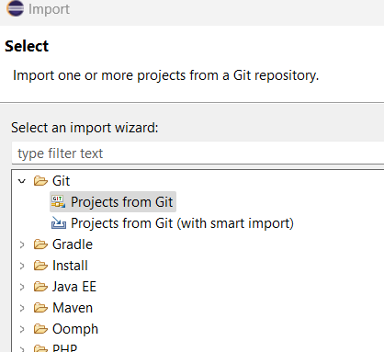  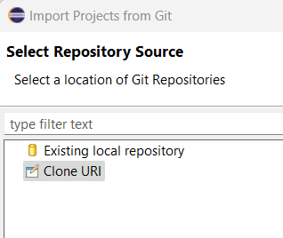

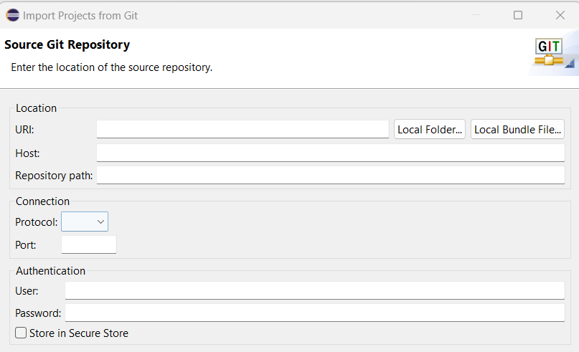

* git stash is a command allows to temporarily save changes in a recycling folder. git stash is a command allows to temporarily save changes in working directory that you are not yet ready to commit. This can be useful when you need to switch branches or work on something else but don't want to commit your incomplete work.

